Learning Journal

**16th February 2021**

Shown examples of what I had to do for some research. I then came up with my Idea for what I wanted one of my tasks to be, this ended up being a main menu with 3 different components, Play button, Settings and a quit button. The play button would of course only take you one scene across. This was simple to understand when you are putting it in the code. You “+1” scene in the build manager when the Play button is pressed.

The settings button keeps you in the same scene but just hides the Play, settings and quit button to the settings screen which has an option for volume. It is a slider which is going between values of 0 – 20. I want to add a graphic option, where you can change the graphic from different resolutions in a drop-down menu and of course a full screen option. This has a back button to go back to the main menu and hide the settings options.

There is a quit button which of course quits the game and takes you out of the game to your desktop.

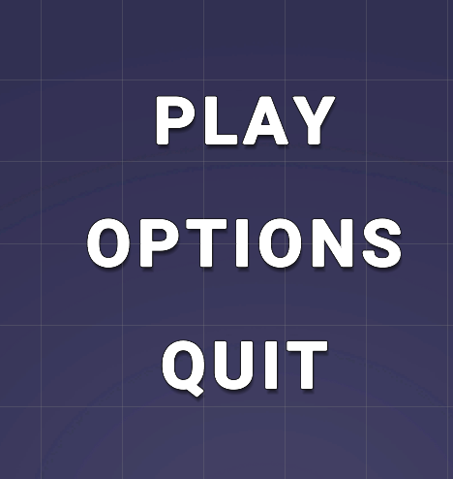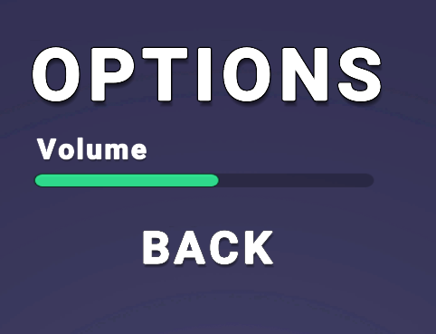



**23rd February 2021**

This is creating a new third Person Controller, this is going to be used for mainly any 3D game that needs it. This is going to make it easier for me to implement it into other games that I do produce as I would not need to make a new controller every time. I first had to create the scene that I wanted and add in a capsule for now to keep the basic shape of a player render and make sure I know what the player is and where he is going to be looking. I added in CineMachine from unity Package managers.

With the New Package Add in the new Camera option called, “Camera Free Look”, On The Orbits in the inspector I made sure that the Top, Middle and Bottom rig are correctly positioned so that it works well and how I wanted it too, and I also changed the Orbit Binding mode to World Space.

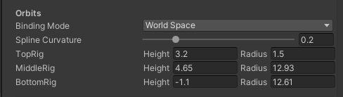

Next I began Creating the Script for the character. 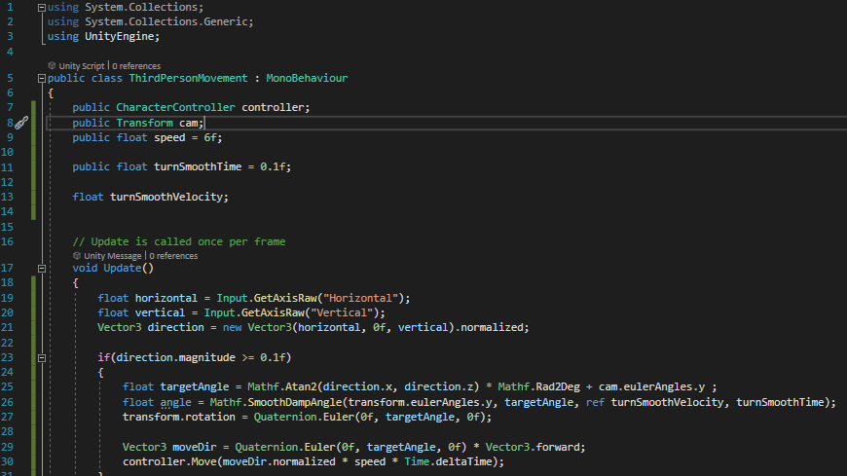

This Script takes into hand to make sure the camera and the character both move together smoothly and make sure everything is working correctly.

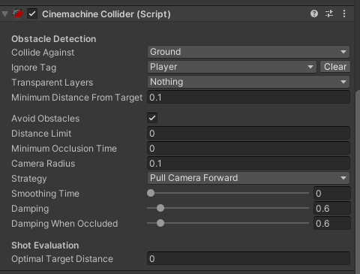

I then added this to the end of the camera, this is basically to make sure that whenever the character looks somewhere it is not going to be obstructed by an object, and specially in this case it’s the Ground Tag.

**2nd March 2021**

This 3rd Package I created was to make it so that when the player is moving the character is staying in orbit of the planet. THis means that he won't go and follow a strict X, Y and Z axis instead he will be going around in circles around a sphere shaped object.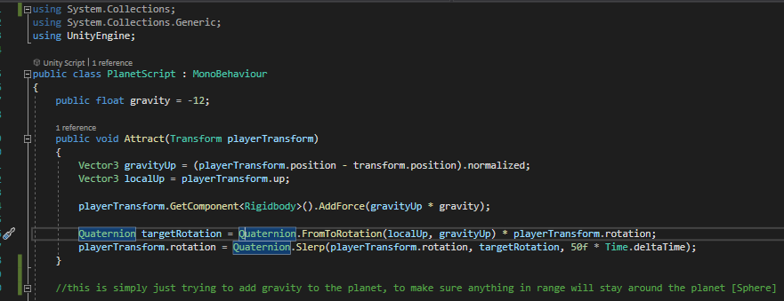

This is basically to make sure that the planet [sphere] has some gravity around it so it makes sure that the character stays in orbit of the planet.

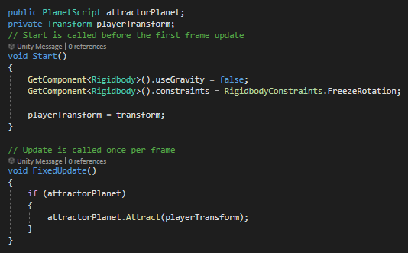

This script is used on the character, it is used to attach the player to the planet so he doesn't fly away or move off axis.

**9th March 2021**

The final script that I have made is so that a player can interact with another NPC in a level and a dialogue box will appear and display some text that you have put in. This can be used for a story game or a small scene where it shows how to do something.

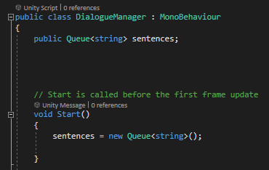

This is my first script for this method and it is the Dialogue Manager, this is a method to keep track of all of the sentences that would appear in the dialogue.

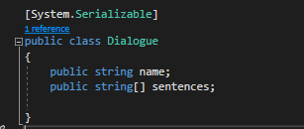

This script called “Dialogue” is used to add in sentences and be used in the Inspector for what you want to add into the game.

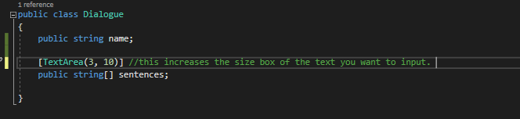

This is a trigger that is going to be put on the object where you want to interact to show the text, like a character or a button in this case. 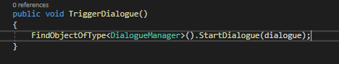

This piece of code is used to demonstrate that when you click on a button on the scene, it will look for an Onclick event you need to have on the button and with that will find a code in the Dialogue manager and play some text. 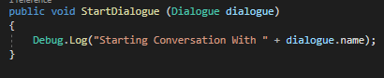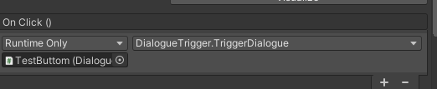

I created a new button for you to then make it so that when you press continue it will continue to the next dialogue that you have placed in the inspector. 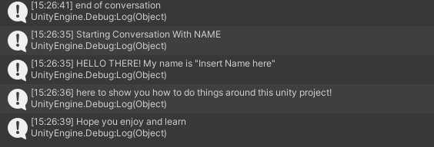

Top Line displays when you press Start, line 2 to 4 is what shows when pressing continue.